The *lrd* Package: An *R* Package and Shiny Application for Processing Lexical Data

Nicholas P. Maxwell1, Mark J. Huff1, and Erin M. Buchanan2

1 The University of Southern Mississippi

2 Harrisburg University of Science and Technology

Author Note

Correspondence concerning this article should be addressed to Nicholas P. Maxwell, School of Psychology, 118 College Dr, Hattiesburg, MS, 39406. E-mail: [nicholas.maxwell@usm.edu](mailto:nicholas.maxwell@usm.edu). The source code for this package as well as all applicable data files have been made available for download at https://osf.io/admyx/. The Shiny application can be accessed at: <https://npm27.shinyapps.io/lrdshiny/> or via www.macapsych.com.

Abstract

Recall testing is a common assessment to gauge memory retrieval. Responses from these tests can be analyzed in several ways; however, the output they generate typically requires manual coding that can be time intensive and error-prone before any analyses can be conducted. To address this issue, this article introduces *lrd* (Lexical Response Data), an open-source tool for quickly and accurately processing lexical response data that can be used either from the *R* command line or through an *R Shiny* graphical user interface. First, we provide an overview of this package and include a step-by-step user guide for processing both cued and free-recall responses. We then validate this program using two methods. First, we use *lrd* to recode output from both cued and free-recall studies with large samples and test whether the results replicate using *lrd* scored data. We then assess the inter-rater reliability and sensitivity and specificity of the scoring algorithm relative to human-coded data. Overall, *lrd* is highly reliable and shows excellent sensitivity and specificity, indicating that recall data processed using this package are remarkably consistent with data processed by a human coder.

Word Count: 184

Keywords: Memory; Cued-Recall; Free-Recall; Lexical retrieval; Recall processing; Recall scoring

The lrd Package: An R Package and Shiny Application for Processing Cued-Recall Data

People are generally able to acquire new knowledge with relative ease. Much of our understanding of how individuals organize and store learned information comes from the use of recall tests (see Polyn, Norman, & Kahana, 2009, a review). These procedures present participants with a set of items to learn within a controlled environment, and following study, participants are asked to recall them on a later test. Recall can either be assessed via free report, in which individuals report information from memory with few if any cues or constraints, or by the presentation of a cue that is used to direct their retrieval. Commonly, cued-recall performance is gauged through the use of cue-target pairs in which participants are required to retrieve a target item at test with the presence of a cue. Recall tests are common in memory research, including studies investigating the effectiveness of different memory strategies (e.g., deep vs. shallow encoding tasks; Craik & Lockhart, 1972), survival processing (e.g., assessing memory for contaminated objects; Gretz & Huff, 2019), and metacognition (e.g., accuracy between judgments of learning and recall; Koriat & Bjork, 2005). Furthermore, because studies often employ words as stimuli (i.e., cue-target pairs), much research has been conducted to explore how the lexical properties of the cue and target can influence later recall (e.g., concreteness, Pavio, Clark, & Khan, 1988; word frequency, Criss, Aue, & Smith, 2011) or how the semantic relationships between pairs affect recall (Nelson, McEvoy, & Schreiber, 2004). Though the research questions differ, recall studies generally employ lexical information in some capacity, either as the stimuli that participants are required to study, the dependent variable of interest, or more commonly, through a combination of the two.

Cued-recall tests are common in psychological research. A cursory search of Google Scholar for the keyword “cued-recall” yields approximately 18,000 publications since 2000, with these results spanning multiple subfields of psychology including neuroscience, psycholinguistics, and cognitive aging. The abundance of these studies can in part be attributed to the rise of the internet and the availability of more powerful computers, which has allowed information about lexical characteristics (such as word length or frequency) to be more efficiently collected and organized. As a result, the past two decades have provided researchers with access a growing number of these normed databases with which to construct lexical stimuli for use within recall studies (e.g., The English Lexicon Project, Balota et al., 2007; The Semantic Priming Project, Hutchison et al., 2013; The Small World of Words Project; De Deyne, Navarro, Perfors, & Brsybaert, 2019). Recently, online tools to aid researchers in selecting stimuli from the appropriate normed database have been made available (e.g., The Linguistic Annotated Bibliography; Buchanan, Valentine, & Maxwell, 2019a) and computer applications such as the *lexOPS* package for *R* ­(Taylor, Beith, & Sereno, 2019) have been developed to automate the stimuli selection process entirely while controlling for several types word properties. Though there has been a proliferation of datasets and tools used to aid researchers with stimuli creation, little attention has been given to developing tools that assist researchers with processing the large amounts of data that are generated from these studies.

Since studies investigating memory typically generate large amounts of lexical data, processing the output obtained from these studies is often a time-consuming and tedious task. Furthermore, the number of participants recruited to take part in these studies has drastically increased within the past decade, partially as a response to the replication crisis (e.g., Maxwell, Lau, & Howard, 2015), which has resulted in an even greater need for efficient methods for processing recall data. As such, the purpose of this paper is to introduce the *lrd* (lexical response data) package, which has been designed to provide researchers with a set of simple and freely accessible tools that can be used to speed up scoring of lexical memory output.

Output from cued-recall tests are generally scored by matching participants’ responses to the various stimuli against a scoring key containing the correct set of responses. Though typed responses are unquestionably easier to process relative to handwritten responses, each response item must still be manually checked against the key to determine accuracy. For large datasets, manually scoring data is arduous, resulting in hours of checking participant responses against an answer key. While such tasks can generally be divided across research assistants in a lab, this may still prove to be a time-consuming endeavor depending on the amount of data requiring processing. Furthermore, this can potentially introduce error in the coded responses, as inconsistencies across raters may arise if not properly controlled for (i.e., addressing participant misspellings, plural vs. singular nouns, alternate tenses, etc.) and scoring discrepancies are not resolved.

To reduce both the overall time spent processing raw output and potential coder inaccuracies, an alternative method is to automate the data coding processes by employing a computer application that can automatically compare participant responses relative to a scoring key. However, simply having a program match responses does not account for participant errors in responses that may still involve a correct memory as these may be scored as incorrect due to misspellings or the addition of an additional character either before or after a memory item such as an extra space. While a human scorer could certainly adjust any minor character additions, omissions, or misspellings to score correctly retrieved memory items, an automated program may not unless a sufficient degree of flexibility is programmed into the scoring package.

The functions comprising the *lrd* package have been specifically designed to accurately score lexical data while granting increased flexibility for minor errors that may be present in recall output. Importantly, this cost-free package has been carefully crafted to require minimal programming experience. The goal of this article is two-fold. First, we provide brief overviews of each function contained in both the *lrd* package in the *R* environment and detail the corresponding *R Shiny* application by providing step-by-step guides on how to implement each of these tools to process both cued-recall and free-recall data. Second, we test the accuracy and reliability of the scoring algorithm by comparing output obtained from this package with human coded data using XX large data sets. Specifically, we test this package’s reliability by using its scoring functions to recode cued-recall data derived from two recent cued-recall studies (Maxwell & Buchanan, 2020; Maxwell & Huff, in press) and XX free-recall studies [CITE]. We then compare data processed using *lrd* to the findings in the original human coded datasets and test whether the original findings reported in these studies replicate. These studies were selected given that all were memory studies that required participants to complete a recall test, their similarity in design, which allowed for easy comparison between each study, and their use of a wide variety of different items to test the reliability of the *lrd* package.

For the two cued-recall studies, participants studied lists of paired associates and judged either how related the words in each pair were (Maxwell & Buchanan, 2020) or how likely they would remember the second word if cued by the first at test using a Judgment of Learning rating (Maxwell & Huff, in press). Upon conclusion of the study/judgment tasks, participants completed a distractor task followed by a cued-recall task in which the first word in each pair was presented and participants were asked to respond with the item it was originally paired with (e.g., mouse - ?). The recall data reported in both of the above studies was initially scored by manually checking responses against a scoring key via human coders. We rescored this output using *lrd* to illustrate that output generated automatically from this package is able to replicate human scored results with a high degree of precision.

For the free-recall studies [EXPAND]

**Overview of the *lrd* Package**

*lrd* is an open-source package developed for the *R* environment that consists of three basic functions for scoring lexical cued-recall data and assessing the output. This package’s primary goal is to automate the scoring process by matching participant responses to a list of correct responses stored in a key. Critically, this package has been designed to accomplish this task while granting flexibility towards participant response errors (e.g., misspellings or incorrect tenses).

We begin by providing a set of general instructions for downloading and installing the *lrd* package within the *R* environment. Next, we provide a basic overview of the scoring functions for both cued and free recall as well as a set of functions that can be used to compute recall proportions for each test type. Third, we provide a general guide on how to use the package within both the *R* environment and through the use of a graphical user interface (GUI) implemented in *Shiny* (RStudio Inc, 2020). Finally, we conclude by assessing the validity of this package by using the cued and free recall scoring functions to process sets of cued and free recall data that have been scored by human coders.

**Installation and Set Up**

Here we present instructions and setup for users wishing to use *lrd* within the *R* environment. Specific instructions for accessing and implementing the *Shiny* application are provided following our description of the *lrd* *R* package.

The latest version of *lrd* (including all applicable documentation and source code for each function) can be accessed via OSF (https://osf.io/admyx/). While proficiency with *R* is not required to run this package, it is assumed that users will have some familiarity with the *R* environment and/or basic experience with object-oriented programming. Installation is relatively straightforward, but currently requires the use of the *devtools* package (Wickham, Hester, & Chang, 2019) to download and install the files from GitHub. Typing the following command, devtools::install_github(‘NPM27/lrd’) will begin the installation process by downloading and installing the latest version of *lrd* along with all dependency packages from GitHub. Source code has been made available on GitHub (https://github.com/npm27/lrd/), and researchers are able to download and modify functions of this package as needed.

**Function 1: Compute the Percent Match Between Response and Key**

The percent_match() function allows for the comparison of a participant’s typed response with the correct response stored in a scoring key. At a minimum, this function requires three user inputs that are then arranged in a dataframe object: A list of participant responses (generally typed responses collected through a computer based data collection tool such as *E-Prime*), a scoring key containing the correct response, and a unique identifier for each participant. The percent match function works by treating each word in the dataframe columns as a string object. This function then computes the percentage of shared characters between a participant’s typed response and the corresponding correct response from the key and returns this value as a new column in the dataframe. The percentages derived by this function are computed bidirectionally to account for any differences in length between the response and key that may arise due to participant errors (i.e., the longer item is always the denominator when computing this percentage). For example, if the word *home* is stored in the scoring key, *lrd* will compute a participant response of *hom* as a 75% percent match with the target due to the absence of one of the four letters (i.e., 25%), while a response of *homme* would be computed as a match of 80% (i.e., the four letters in the original word divided by the five letters in the response). Table 1 illustrates how output obtained using percent_match()is formatted.

Since percent_match()relies on the length of the two words being compared when computing this percentage, shorter words are more likely to have lower percent matches and are thus at a disadvantage relative to longer words. This is because typos and misspellings will have a greater negative impact on short words when this percentage is calculated. Table 1 provides an example of this. Looking at the percent match column, the participant responses for the items *home* and *windshield* each contain one typo relative to the answer key. However, because *home* is a four-letter word, the negative impact that this misspelling has on the percent match is magnified relative to when the ten-letter word *windshield* is misspelled. To account for this, percent_match()also includes an optional “weighted” argument, should researchers wish to control for item length when processing responses. By activating this argument (weight.by = TRUE), the user is able to specify a value that is then used to adjust the percent match values. The weighted percent match is then computed using the following formula:

(1)

In Equation 1, *p* represents the percentage of shared characters between the participant response and its corresponding answer key (i.e., the percent match between the two), *v* is a user specified weight value ranging from 0 to .99 that is specified using the weight.by argument, and *c* equals the total number of characters comprising the correct response (as stored in the answer key). Weighted match values computed from Equation 1 are then stored in a separate vector which is appended to the dataframe, rather than overwriting the initial, unweighted percent match values. The inclusion of both columns allows the user to see what improvements in scoring accuracy occur by using the weighed match method relative to using the non-weighted percent match values.

**Function 2: Score Responses as Correct or Incorrect Based on Percent Match**

The second function comprising *lrd* is the score_recall() function. This function operates by taking the saved output from percent_match() and using values stored in the percent match column to determine whether an item was recalled correctly. Using the set.cutoff argument, the user is able to specify a cutoff value that *p* must eclipse in order for the response to be marked as correct. For example, if the cutoff value is set at 0.80, then responses that are at least an 80% match (i.e., *p* ≥ .80)would be marked as correct. Because the user is able to freely specify a desired cutoff point, this allows the scoring algorithm to be tuned to the dataset being processed.

Using score_recall() returns a .csv file saved to the working directory. The first three columns of this file contain the three initial inputs used when computing the percent match (i.e., participant number, participant response, and answer key). The remaining columns denote the percentage of characters shared between the response and the key, the weighted version of this percentage (if applicable), whether the item was recalled correctly. Scores are represented as a series of 0’s and 1’s denoting whether the item was correctly recalled (i.e., 0 = incorrect, 1 = correct). Table 1 illustrates the structure of the output file. Because *lrd* does not change the row order of the input file, any additional columns (such as those denoting experimental conditions) can then be appended to the scored output.

**Function 3: Compute the Proportion of Correct Responses**

The final function included with *lrd* is prop.correct(). This function operates on the scored output and provides a means for quickly assessing each participant’s mean recall score. At minimum, this function requires the user to provide two inputs: A dataframe column consisting of item scores (e.g.., scores generated using the score_recall() function) and a column containing participant identifiers, which is specified using the id argument. This will return a dataframe object consisting of each participant’s mean recall score collapsed across any experimental conditions and automatically computes *z*-scores (see Table 2 for an illustration of how this output is formatted). If the scored output contains additional columns denoting experimental conditions, then these can be used to group the participant means. Using the group.by argument, the user can specify one column that can be used as a grouping variable. Mean recall scores will then be displayed for each participant at each level of the grouping variable. Finally, if a researcher wishes to compute condition means collapsed across participants, the id argument can be set to a condition column.

**Function 4: [ARRANGE FREE RECALL]**

[WORDS HERE]

**Function 5: [SCORE FREE RECALL]**

[WORDS HERE]

**Function 6: [FREE RECALL PROPORTION CORRECT]**

[WORDS HERE]

**Function 7: [FREE RECALL SENTENCES]**

[WORDS HERE]

**Scoring Functions Example**

In this section, we provide a guide to using *lrd* to score lexical response data within the *R* environment. This example uses a two sets of simulated response data that were designed to mimic output that might be obtained from both a cued-recall and free recall studies. While these dataset is smaller than what is typically generated from psychological experiments, we note that they are sufficient for our purpose of illustrating how *lrd* scores participant responses. We begin this section by detailing the creation of this dataset before providing a step-by-step walkthrough of the *lrd* package’s scoring functions.

**Materials and Dataset Creation: Cued-Recall**

To simulate a set of cued-recall data, forty words were randomly generated using *LexOPS* (Taylor et al., 2019) to serve as target items (i.e., the scoring key containing correct responses). To simplify the stimuli selection process, we followed the general example provided by Taylor et al. by controlling for word prevalence and concreteness when generating this set of items. First, only highly concrete words were included (concreteness ≥ 4; Brysbaert, Warriner, & Kuperman, 2014). Pairs were then evenly split based on word prevalence (e.g., the proportion of individuals who are familiar with a word; Brysbaert, Mandera, McCormick & Keuleers, 2019). Thus, the final stimuli consisted of 20 concrete, high prevalence words (i.e., prevalence ≥ 4) and 20 concrete, low prevalence words (i.e., prevalence ≤ 2).

We next simulated five sets of participant responses to these items. These response simulations varied in their degree of accuracy to cover a broad spectrum of potential participant responses, including no response errors (Participant 1), minor misspellings (Participants 2 and 3), and major response errors (e.g., blank responses, incorrect answers, misspellings of more than two letters, Participants 4 and 5). For Participant 1, all responses matched the key to simulate a situation in which a participant correctly recalls all items. Data for Participants 2 and 3 was manipulated to simulate situations in which participants make minor mistakes at recall that don’t necessarily preclude them from being counted as correct (e.g., misspellings where it is evident what the intended word is). These were generated by removing, replacing, or doubling specific letters. As such, the letter “e” was removed from all responses for subject 2 (e.g., “hey” becomes “hy”). For Participant 3, the letter “i” was removed from all pairs, all instances of the letter “e” were replaced with “a”, and “y” was replaced with “yy” (e.g., “you” becomes “yyou”). This allowed us to simulate a range of common participant errors such as omitting a letter, typing the wrong letter, or double pressing a key by mistake. Finally, data for Participants 4 and 5 were manipulated to simulate situations in which participants make major mistakes on recall (e.g., test responses with an incorrect word). To simulate this type of response error for Participant 4, five responses from the answer key were randomly changed to a different but conceptually similar word (e.g., *fuel* becomes *gas*). The simulated data for Participant 5 increased the number of incorrect responses and added three instances of missing data. Finally, to simulate a situation in which participant responses are highly similar to the scoring key, we simulated data for a sixth participant using a set of 40 homophones. Specifically, responses for Participant 6 were constructed such that the response to the cue was always a homophone of the correct target (i.e., a response of *dear* when the correct response is *deer*). Both the sample dataset (test_data.csv) and the code used to generate it have been made available for download at https://osf.io/admyx.

**Materials and Dataset Creation: Free Recall**

[WORDS HERE]

**Formatting and Loading a Dataset**

The *lrd* package requires that the initial input data is formatted as .csv with a header row. This file will need to be arranged in long format and must contain the following three columns: A unique identifier for each participant, an answer key containing the correct responses, and a list of participant responses. This upload file may contain additional columns, but they will not be processed by *lrd.* However, any additional columns can be appended to the final output after data has been processed. The scoring functions are case sensitive and thus the response and answer key columns will need to be checked for case discrepancies. For simplicity, we suggest converting both the answer key and response columns to lowercase before scoring the data. Finally, any missing responses will need to be converted from NAs to blanks.

[R CODE]

## set up

library(lrd)

dat = read.csv("test_data.csv")

summary(dat)

# make sure everything is lowercase

dat$Response = tolower(dat$Response)

# replace response NAs with blanks

dat$Response[is.na(dat$Response)] = ""

[SPECIAL INSTRUCTIONS FOR FREE RECALL FORMATTING HERE]

**Scoring Cued-Recall Data**

Scoring the data with *lrd* is a relatively straightforward process. To begin, run percent_match()and save the output as a new object (see code below for an example). When running this function, you will need to specify the columns containing the participant responses, the answer key, and the subject number. This function will then return a dataframe object containing the three input columns and a new column that denotes the percentage of characters shared between the participant response and the answer key. Recall can then be scored by running the score_recall()function on the stored output. This function requires specifying the cutoff score for percent match (for this example, we used a cutoff of 75%). The output of this function is saved to the working directory as a .csv file named “output.csv.” This file contains the three initial input columns used for computing the percent match, the percent match column, and a column denoting whether an item was correctly recalled. To illustrate how changes in the percent match cutoff value influence final scores for various types of participant errors, Table 3 displays a subset of the scored output (one word per participant) at matches of 50%, 75%, and 100% (the full output file generated from this example has been made available on our OSF page).

[R CODE]

# Compute percent match

matched = percent_match(dat$Response, key = dat$key, id = dat$subID)

# Now score the output using a 75% match to compute scores

# Note that score_recall automatically stores output in a .csv file

score_recall(matched, set.cutoff = .75)

**Scoring Free Recall Data**

[WORDS HERE]

**R Shiny Applications**

While *lrd* was initially designed as a package to be used within the *R* command environment, we recognized the need for an easy to access option that can be used independent of *R*. As such, we have also developed a pair of *Shiny* applications that provide researchers with a programming-free alternative to using this tool that can be operated using basic Excel skills. Furthermore, because this application is web based (cued-recall available at https://npm27.shinyapps.io/lrdshiny; free recall available at [LINK]), no software downloads are required.

**Cued-Recall Shiny Application**

The cued-recall *lrd Shiny* application consists of four tabs: An instructions tab and three output tabs that display a preview of the scored dataset, tables showing mean correct responses, and plots that can be used for basic data visualization (Figures 1-4 display the various tabs). To begin the scoring process, a .csv file will need to be uploaded to the application. This file will need to contain at least three columns that have been arranged in the following order: A unique participant identifier, a scoring key, and a set of participant responses. The input file may also contain additional columns (e.g., optional columns denoting experimental conditions), however, these columns must be placed starting with the fourth column. To begin the file upload process, the input settings must first be selected (e.g., the type of separator used). Next, the scoring criteria must be specified. The application defaults to using a 75% match, but a slider has been provided to make simple online adjustments to scoring cutoffs. The strictest option available is a 100% match, however, this can be decreased down to a 50% match (all 1% increments between 100% and 50% are available). Changes in scoring that occur due to updating the percentage correct are reflected in the across the three output tabs in real time. Thus, researchers can quickly assess how different scoring criteria affect their data and can fine-tune the scoring algorithm to meet their individual needs. Once all options have been selected, the file can be uploaded (see Figure 1 for an example of how to configure the input settings).

After the input file has been uploaded, a preview of the scored data will appear in the “Scored Output” tab. A download button located at the top of this tab can be used to save the scored data as a .csv file (see Figure 2). Each participant's mean proportion of correct responses and corresponding *z*-score can be viewed using the "Proportion Correct" tab. The output displayed in this tab can be customized based on any of the optional condition columns that are attached to the upload .csv file (data can be split on up to two experimental conditions at a time, which are selected using a set of drop-down menus; see Figure 3), however, *z*-scores will only be displayed when grouping a dataset by one condition (e.g., showing each participant’s mean proportion correct or collapsing across participant to show condition means). As with the scored output, proportion correct values can be saved as a .csv file using the download button located at the top of the tab. Finally, the "Plots" tab can be used to visualize the scored data. As with the proportion correct, these plots can also be customized based on any of the optional condition columns uploaded with the dataset to conditionalize the visual output as a function of item type or other grouping variable (see Figure 4). If no condition columns are included with the upload file, this tab will instead display a histogram showing the distribution of participant responses (this can also be viewed at any time by selecting the participant identifier as the grouping condition).

**Free Recall R Shiny Application**

[WORDS HERE]

**Cued-Recall Scoring Functions Validation**

In the next section, we report results from two sets of analyses in which we tested the cued-recall scoring accuracy of *lrd*. Each analysis serves as an additional assessment to ensure *lrd* can consistently produce accurate scoring across different sets of stimuli. First, we use *lrd* to score the datasets used for each set of analyses. These data were derived from two sources: Maxwell and Buchanan (2020) and Maxwell and Huff (in press). We then conducted three sets of analyses to test the reliability of this package. First, we tested whether the results of these studies would significantly differ from the original findings after the raw data was processed and scored using *lrd*, allowing us to test the accuracy of this package at the participant level. Finally, we computed Cohen’s *κ* to assess reliability between the different coding sources.

We begin this section by providing details for each dataset, including participant and stimuli characteristics for reach study. We then discuss the selection criteria for the percent match value and detail the results of a set of sensitivity and specificity analyses that were used to test potential cutoff values and provide a step-by-step walkthrough of the scoring process. Finally, we conclude this section by detailing each of the analyses described above.

**Participants and Materials**

Each dataset was collected separately across two different experimental settings. The first set of participants was originally reported in Maxwell and Buchanan (2020; dataset available at https://osf.io/y8h7v/). This dataset consists of 222 participants who were recruited online via Amazon’s Mechanical Turk, a site which allows researchers to access a large pool of participants who complete surveys in exchange for small sums of money (Buhrmester, Kwang, & Gosling, 2011). Next, Maxwell and Huff’s (in press) data consists of 112 undergraduate students who were recruited from The University of Southern Mississippi’s psychology research pool and tested in lab (dataset available at https://osf.io/hvdma/). These participants completed the study in exchange for partial course credit and were recruited to take part in one of four experiments. For purposes of this paper, we collapsed across experiment to include all 112 subjects in one dataset. Combining datasets across both studies resulted in 31,301 recall entries generated from 334 participants.

Datasets were selected due to their similarity in design. Each study presented participants with paired associate study lists and later had them complete cued-recall tasks. Furthermore, each study contained reasonably sized samples (all *n*s > 90) and presented participants with at least 60 item pairs to study, providing us with a sufficient number of observations with which to test the reliability of this package. Each study presented participants with a set of cue-target paired associates (e.g., credit – card). Participants were asked to study each pair before making a judgment of either the pair’s relatedness or their ability to recall the pair at test. After completing the study and judgment tasks, participants then complete a cued-recall test. While participant judgments were collected in each experiment, they are not included in the following analyses as we are only interested in analyzing the accuracy of *lrd* in scoring recall responses.

First, Maxwell and Buchanan (2020) used 63-word pairs that were selected using the Buchanan et al. (2013) semantic feature overlap norms. The stimuli pairs used in this study were selected based on the strength of their semantic relatedness as measured by cosine overlap (See Buchanan, Valentine, and Maxwell (2019b) for a review of cosine overlap) while also controlling for association strength and thematic similarity. Next, the Maxwell and Huff (in press) dataset used 180 study pairs selected from the University of South Florida Free Association norms (USF norms, Nelson et al., 2004). Stimuli pairs used in this study were originally selected based on their levels of forward associative strength (FAS) and backward associative strength (BAS).

Each of these studies assessed participant recall using the same method. After conclusion of the study tasks, participants completed a cued-recall test in which the first item of each study pair was presented with the second item removed (e.g., *mouse - ?*). Participants in each study were informed that they would not be penalized for guessing or incorrect spellings of answers.

**Determining the Optimal Percent Match Cutoff Value**

Given the *lrd* package’s scoring functions work by computing the number of characters shared between two strings (i.e., the percent of characters that are the same between two words), we first needed to determine the optimal cutoff value for the percent match function that would maximize the number of correct hits (e.g., true positives) while minimizing the number of false positives and false negatives. To determine this value, we conducted a set of sensitivity and specificity analyses for each dataset (see Altman & Bland, 1994, for review). Within the context of this study, sensitivity refers to the proportion of true positives that *lrd* correctly identifies (i.e., a participant correctly responds to the target and the program correctly identifies it), while specificity refers to the proportion of true negatives identified by the program (i.e., the program correctly identifies that a participant missed an item on the recall test).

Sensitivity and specificity analyses were computed in *R* using the *caret* package (Kuhn, 2008). Because computing sensitivity and specificity require that all tested cutoff points be selected a priori, we selected ten percentage values from 55% to 100% at 5% intervals to serve as sample cutoff values (see Tables 4 and 5 for the selected percentages). We note, however, that percent matches below 50% were not included because at a match rate of less than 50%, the majority of characters within each pair would be incorrect, and furthermore, any matching characters would likely be due to chance.

Tables 4 and 5 report sensitivity and specificity percentages for each dataset computed across of the ten tested cutoff points. Overall, both datasets displayed a consistent pattern of results: Sensitivity and specificity were each maximized when the percent match cutoff value was set to 75%, suggesting that this value allowed the scoring algorithm to achieve maximum accuracy. We therefore suggest that 75% provides the optimal cutoff value for minimizing false positives and negatives; however, the program allows researchers to increase or decrease the cutoff value as desired.

**Data Processing and Scoring**

To assess the reliability of the *lrd* package, we next used its two primary scoring functions to process and score the two cued-recall datasets introduced above. We then compared output obtained through this scoring process to the original, manually coded output originally reported in these studies and tested whether the original findings would replicate.

Prior to running the scoring algorithm, .csv files consisting of the participant responses, answer key, and unique identifiers for each participant were created for each of the three datasets. Data from each study were then scored using the percent_match() and score_recall() functions. Scoring was an iterative process which used each percent match from the sensitivity and specificity analyses plus a percent match of 50%. Thus, each dataset was scored 11 times (once for each percent match cutoff value). This allowed us to track how changing the percent match criteria affected scoring accuracy.

**Analyses and Results**

After determining the optimal range of cutoff values to use with the scoring functions, we now turn to a set of analyses that test whether the data scored using *lrd* can successfully reproduce the results from each of the original manually scored datasets. We begin this section by providing descriptive statistics of recall rates for both the original and rescored datasets and then test whether these recall rates differ as a function of coder. Finally, we compute the inter-rater reliability between the human coded and *lrd* scored data. Each dataset was analyzed individually, providing us with two separate tests of the *lrd* package’s scoring accuracy. For all analyses, significance was set at the *p* < .05 level.

**Replication of Cued-Recall Studies**

First, each dataset was scored with *lrd* using 10 percent match cutoff values between 55% and 100% used in the sensitivity and specificity analyses. Additionally, we included 50% because it represents the minimum acceptable cutoff value, bringing the total number of cutoff values tested to 11. Next, two one-way Analysis of Variance (ANOVA) models were used on each dataset to test whether recall rates differed between the 12 scoring types (the 11 *lrd* scoring criteria plus the human coded data). For completeness, means, 95% CI’s and Cohen’s *d* effect size indices for all comparisons are reported in Tables 6 and 7.

Starting with the Maxwell and Buchanan (2020) dataset, no significant differences were detected between the human coded data or the *lrd* scored data at any of the percent match cutoff values, *F*(11, 2652) = 0.62, *MSE* = 735.97, *p* = .81. For the Maxwell and Huff (2020) dataset, a significant effect of scoring type was detected, *F*(11, 1332) = 2.92, *MSE* = 188.09, *p* < .001, *η*p2 = .02. However, post-hoc analyses revealed that this effect was largely driven by the 50% *lrd* scoring condition, as mean recall in this condition (47.92) significantly differed from all other conditions (*t*s ≥ 2.08, *d*s ≥ 0.28), with the exception of the 60% (45.21) and 55% (45.58) cutoff criteria (*t*s ≤ 1.50). Additionally, the 50% scoring condition was the only set of *lrd* scored data which significantly differed from the human scored data, *t*(221) = 2.15, *SEM* = 1.85, *p* = .03, *d* = 0.29. Recall rates did not differ between the human coded data (43.96) and any of the other *lrd* cutoff points. Thus, using *lrd* to score participant responses did not result in significant changes in outcome across any of the experiments, particularly when an optimized cutoff of 75% from the sensitivity and specificity analyses was used. As such, these findings suggest that this package is able to code lexical data equivalently to human coders.

**Inter-Rater Reliability**

To test the inter-rater reliability between the original data and the rescored data, we computed *κ* values for all data sets at the individual trial level. These values were computed in *R* using the *psych* package (Revelle, 2019). The *κ* statistic ranges from -1 to 1, and inter-rater reliability is considered strong if *κ* exceeded .80 (Cohen, 1960).

Beginning with the Maxwell and Buchanan (2020) data, a strong agreement was detected between the human coded data and each of the 11 *lrd* scored response sets, *κ*s ≥ .90. The Maxwell and Huff (in press) dataset showed a similar pattern of agreement between coding methods, *κ*s ≥ .89. Table 8 reports individual *κ* statistics for all comparisons within each dataset. Across datasets, reliability between human and *lrd* scored data was highest when a percent match of 75% was used, and lowest when a percent match of 50% was used. As such, these results provide further evidence that using *lrd* to score cued-recall responses results in output that is highly consistent with what is produced by human coders.

**Free Recall Scoring Functions Validation**

[WORDS HERE]

**Participants and Materials**

[WORDS HERE]

**Data Processing and Scoring**

[WORDS HERE]

**Analyses and Results**

[WORDS HERE]

**Replication of Free Recall Studies**

[WORDS HERE]

**Inter-Rater Reliability**

[WORDS HERE]

**Summary and Conclusion**

Although recall tests are widely used in Psychology, no open access tools currently exist to quickly process the large amounts of lexical data that these studies generate. The *lrd* package addresses this need by providing researchers with a means of automating both cued and free recall scoring as a means to save time and minimize coding errors. This package allows researchers to quickly and accurately score large amounts of lexical output, while also being able to control for minor errors in participant responses. Our analyses indicate that data scored using *lrd* accurately reproduces manually coded data by using this package to replicate the results of two cued-recall studies and by testing the reliability of its output relative to human coded data. We hope that *lrd* will both drastically reduce the amount of time spent coding lexical data and assist the reproducibility measures being adopted by the field by providing researchers with a standardized, open-source method for processing lexical output across psychological studies.

**Open Practices Statement**

The data for all experiments have been made available at https://osf.io/admyx/ and none of the experiments were preregistered.

References

Altman, D. G., & Bland, J. M. (1994). Diagnostic tests. 1: Sensitivity and specificity. *BMJ (Clinical research ed.)*, *308*(6943), 1552.

Balota, D. A., Yap, M. J., Hutchison, K. A., Cortese, M. J., Kessler, B., Loftis, B., Neely, J. H., Nelson, D. L., Simpson, G. B., & Treiman, R. (2007). The English lexicon project. *Behavior Research Methods 39*, 445-459.

Brysbaert, M., Mandera, P., McCormick, S. F., & Keuleers, E. (2019). Word prevalaence norms for 62,000 English lemmas. *Behavior Research Methods, 51*, 467-479.

Brysbaert, M., Warriner, A. B., & Kuperman, V. (2014). Concreteness ratings for 40 thousand generally known English word lemmas. *Behavior Research Methods, 46*, 904-911.

Buchanan, E. M., Holmes, J. L., Teasley, M. L., & Hutchison, K. A. (2013). English semantic word-pair norms and a searchable web portal for experimental stimulus creation. *Behavior Research Methods, 45*, 746-757.

Buchanan, E. M., Valentine, K. D., & Maxwell, N. P. (2019a) LAB: Linguistic Annotated Bibliography – a searchable portal for normed database information. *Behavior Research Methods, 51*, 1878-1888.

Buchanan, E. M., Valentine, K. D., & Maxwell, N. P. (2019b) English semantic feature production norms: An extended database of 4436 concepts. *Behavior Research Methods. 51*, 1849-1863.

Burhmester, M., Kwang, T., & Gosling, S. D. (2011). Amazon’s Mechanical Turk: A new source of inexpensive, yet high-quality data? *Perspectives on Psychological Science, 6*(1), 3-5.

Cohen, J. (1960). A coefficient of agreement for nominal scales. *Education and Psychological Measurement, 20,* 37-46.

Craik, F. I. M. & Lockhart, R. S. (1972). Levels of processing: A framework for memory research. *Journal of Verbal Learning and Verbal Behavior, 11*(6), 671-684.

Criss, A. H., Aue, W. R., & Smith, L. (2011). The effects of word frequency and context variability in cued recall. *Journal of Memory and Language, 64*(2), 119-132.

De Deyne, S., Navarro, D. J., Perfors, A., Brysbaert, M., & Storms, G. (2019). The “Small World of Words” English word association norms for over 12,000 cue words. *Behavior Research Methods, 51*, 987-1006.

Gretz, M. R. & Huff, M. J. (2019). Did you wash your hands? Evaluating memory for objects touched by healthy individuals and individuals with contagious and noncontagious diseases. *Applied Cognitive Psychology, 33*(6), 1271-1278.

Hutchison, K. A., Balota, D. A., Neely, J. H., Cortese, M. J., Cohen-Shikora, E. R., Tse, C.-S., … Buchanan, E. M. (2013). The semantic priming project. *Behavior Research Methods, 45*(4), 1099–1114.

Koriat, A., & Bjork, R. A. (2005). Illusions of competence in monitoring one’s knowledge during study. *Journal of Experimental Psychology: Learning, Memory, and Cognition, 31*(2), 187-194.

Kuhn, M. (2008). Building predictive models in R using the caret package. *Journal of Statistical Software, 28*(5), 1-26.

Maxwell, N. P. & Buchanan, E. M. (2020). Investigating the interaction of direct and indirect relation on memory judgments and retrieval. *Cognitive Processing, 21*, 41-53.

Maxwell, N. P. & Huff, M. J. (2020). The deceptive nature of associative word pairs: The eﬀects of associative direction on judgments of learning. *Psychological Research*, 1-19.

Maxwell, S. E., Lau, M. Y., & Howard, G. S. (2015). Is psychology suffering from a replication crisis? What does “failure to replicate” really mean? *American Psychologist, 70*(6), 487-498.

Nelson, D. L., McEvoy, C. L., & Schreiber, T. A. (2004). The University of South Florida free association, rhyme, and word fragment norms. *Behavior Research Methods, Instruments, & Computers, 36*, 402-407.

Pavio, A., Clark, J. M., & Khan, M. (1988). Effects of concreteness and semantic relatedness on composite imagery ratings and cued recall. *Memory & Cognition, 16*, 422-430.

Polyn, S. M., Norman, K. A., & Kahana, M. J. (2009). A context maintenance and retrieval model of organizational processes in free recall. *Psychological Review, 116*(1), 129-156.

Revelle, W. (2019). psych: Procedures for Psychological, Psychometric, and Personality Research. Northwestern University, Evanston, Illinois. R package version 1.9.12, Retrieved from https://CRAN.R-project.org/package=psych.

RStudio Inc (2015). Easy web applications in R. [computer software manual]. (http://www.rstudio.com/shiny/).

Taylor, J. E., Beith, A., & Sereno, S. C. (2019). LexOPS: An R Package and user interface for the controlled generation of word stimuli. Retrieved from https://github.com/JackEdTaylor/LexOPS

Wickham, H., Hester, J., & Chang, W. (2019). Devtools: Tools to make developing R packages easier. R package version 2.2.1 Retrieved from https://CRAN.R-project.org/package=devtools

Table 1

|  |  |  |  |  |
| --- | --- | --- | --- | --- |
| Participant | Response | Key | Percent Match | Weighted Match |
| 1 | hom | home | 75% | 0.88 |
| 1 | windsheld | windshield | 90% | 0.95 |
| 1 | pepper | pepper | 100% | 1.00 |
| 2 | homme | home | 80% | 0.93 |
| 2 | windsheild | windshield | 100% | 1.00 |
| 2 | pepper | pepper | 100% | 1.00 |

*Sample Output Obtained using the percent_match()Function*

*Notes.* This example uses a weighting criteria of 0.5. Because *lrd* computes percent match values based on matching characters, the position of the characters within the string does not matter. Thus, *windsheild* and *windshield* will each be counted as 100% matches.

Table 2

|  |  |  |
| --- | --- | --- |
| Participant | Mean Proportion Correct | *z* Proportion Correct |
| 1 | 0.25 | -2.41 |
| 2 | 0.75 | -0.09 |
| 3 | 0.75 | -0.09 |
| 4 | 0.75 | -0.09 |
| 5 | 1.00 | 1.07 |

*Sample Output Obtained using the prop.correct()Function*

Note: Example data was scored using a 75% match. Full example data is available at https://osf.io/b74xe/.

Table 3

|  |  |  |  |  |  |  |
| --- | --- | --- | --- | --- | --- | --- |
| Participant | Response | Key | Percent Match | *lrd* 100% | *lrd* 75% | *lrd* 50% |
| 1 | halo | halo | 100% | 1 | 1 | 1 |
| 2 | bak | bake | 75% | 0 | 1 | 1 |
| 3 | waxxy | waxy | 80% | 0 | 1 | 1 |
| 4 | fuel | gas | 0% | 0 | 0 | 0 |
| 5 | hall | hallway | 57.14% | 0 | 0 | 1 |
| 6 | course | coarse | 83.33% | 0 | 1 | 1 |

*Example of Different types of Participant Response Errors*

*Notes.* Participant 1 provided the correct response; Participant 2 omitted one letter; Participant 3 included one extra letter; Participant 4 responded with a synonym; Participant 5 responded with a shortened form of the word; Participant 6 responded with a homophone.

Table 4

|  |  |  |
| --- | --- | --- |
| Cutoff Criteria | % Sensitivity | % Specificity |
| 100% Match | 99.94 | 94.41 |
| 95% Match | 99.94 | 94.41 |
| 90% Match | 99.91 | 94.72 |
| 85% Match | 99.91 | 95.25 |
| 80% Match | 99.61 | 96.08 |
| 75% Match | 99.16 | 96.72 |
| 70% Match  65% Match  60% Match  55% Match | 98.63  98.25  97.26  97.13 | 96.72  96.79  96.80  96.80 |

*Sensitivity and Specificity Results for Maxwell and Buchanan (2020)*

*Note.* Percent matches of 50% or lower were excluded from this set of analyses.

Table 5

|  |  |  |
| --- | --- | --- |
| Cutoff Criteria | % Sensitivity | % Specificity |
| 100% Match | 99.73 | 92.43 |
| 95% Match | 99.73 | 92.43 |
| 90% Match | 99.73 | 92.59 |
| 85% Match | 99.70 | 93.76 |
| 80% Match | 98.98 | 96.18 |
| 75% Match | 98.67 | 97.07 |
| 70% Match  65% Match  60% Match  55% Match | 98.36  97.69  96.21  95.67 | 97.12  97.45  98.05  98.19 |

*Sensitivity and Specificity Results for Maxwell and Huff (in press)*

*Note.* Percent matches of 50% or lower were excluded from this set of analyses.

**Table 6**

*Effect Size Differences (Cohen’s d) as a Function of Human Coded and lrd Scored Data Collapsed Across Item Type in Maxwell and Buchanan (2020).*

|  |  |  |  |  |  |  |  |  |  |  |  |  |
| --- | --- | --- | --- | --- | --- | --- | --- | --- | --- | --- | --- | --- |
| Group | *M* | HC | 100% | 95% | 90% | 85% | 80% | 75% | 70% | 65% | 60% | 55% |
| Human Coded | 54.14 (3.47) | -- |  |  |  |  |  |  |  |  |  |  |
| *lrd* 100% | 50.81 (3.60) | 0.12 | -- |  |  |  |  |  |  |  |  |  |
| *lrd* 95% | 50.81 (3.60) | 0.12 | 0.00 | -- |  |  |  |  |  |  |  |  |
| *lrd* 90% | 50.72 (3.60) | 0.12 | 0.00 | 0.00 | -- |  |  |  |  |  |  |  |
| *lrd* 85% | 51.18 (3.59) | 0.11 | 0.01 | 0.01 | 0.00 | -- |  |  |  |  |  |  |
| *lrd* 80% | 51.77 (3.57) | 0.09 | 0.02 | 0.02 | 0.01 | 0.02 | -- |  |  |  |  |  |
| *lrd* 75% | 52.32 (3.58) | 0.07 | 0.03 | 0.03 | 0.05 | 0.04 | 0.02 | -- |  |  |  |  |
| *lrd* 70% | 52.56 (3.59) | 0.07 | 0.06 | 0.06 | 0.06 | 0.05 | 0.03 | 0.01 | -- |  |  |  |
| *lrd* 65% | 52.77 (3.59) | 0.05 | 0.07 | 0.07 | 0.07 | 0.06 | 0.04 | 0.02 | 0.00 | -- |  |  |
| *lrd* 60% | 53.24 (3.57) | 0.03 | 0.10 | 0.10 | 0.10 | 0.08 | 0.06 | 0.04 | 0.03 | 0.02 | -- |  |
| *lrd* 55% | 53.29 (3.57) | 0.02 | 0.10 | 0.10 | 0.09 | 0.08 | 0.06 | 0.05 | 0.03 | 0.03 | 0.00 | -- |
| *lrd* 50% | 55.27 (3.50) | 0.04 | 0.17 | 0.17 | 0.16 | 0.15 | 0.13 | 0.11 | 0.10 | 0.09 | 0.07 | 0.07 |

*Note.* Mean recall rates for each scoring condition. *95%* *CI*’s are in parentheses. HC = Human coded data. HC and percentage columns indicate Cohen’s *d* effect sizes for post-hoc comparisons, * = *p* < .05.

**Table 7**

*Effect Size Differences(Cohen’s d) as a Function of Human Coded and lrd Scored Data Collapsed Across Associative Direction Items in Maxwell and Huff (in press).*

|  |  |  |  |  |  |  |  |  |  |  |  |  |
| --- | --- | --- | --- | --- | --- | --- | --- | --- | --- | --- | --- | --- |
| Group | *M* | HC | 100% | 95% | 90% | 85% | 80% | 75% | 70% | 65% | 60% | 55% |
| Human Coded | 43.96 (2.61) | -- |  |  |  |  |  |  |  |  |  |  |
| *lrd* 100% | 40.78 (2.51) | 0.23 | -- |  |  |  |  |  |  |  |  |  |
| *lrd* 95% | 40.78 (2.51) | 0.23 | 0.00 | -- |  |  |  |  |  |  |  |  |
| *lrd* 90% | 40.85 (2.51) | 0.23 | 0.00 | 0.00 | -- |  |  |  |  |  |  |  |
| *lrd* 85% | 41.37 (2.52) | 0.20 | 0.02 | 0.02 | 0.02 | -- |  |  |  |  |  |  |
| *lrd* 80% | 42.85(2.55) | 0.11 | 0.12 | 0.12 | 0.11 | 0.10 | -- |  |  |  |  |  |
| *lrd* 75% | 43.41 (2.55) | 0.06 | 0.16 | 0.16 | 0.16 | 0.14 | 0.04 | -- |  |  |  |  |
| *lrd* 70% | 43.61 (2.56) | 0.04 | 0.18 | 0.18 | 0.18 | 0.16 | 0.06 | 0.02 | -- |  |  |  |
| *lrd* 65% | 44.13 (2.55) | 0.00 | 0.23 | 0.23 | 0.23 | 0.20 | 0.11 | 0.07 | 0.05 | -- |  |  |
| *lrd* 60% | 45.21 (2.55) | 0.07 | 0.29* | 0.29* | 0.29* | 0.27* | 0.18 | 0.13 | 0.11 | 0.07 | -- |  |
| *lrd* 55% | 45.57 (2.55) | 0.09 | 0.32* | 0.32* | 0.32* | 0.30* | 0.20 | 0.16 | 0.14 | 0.09 | 0.03 | -- |
| *lrd* 50% | 47.93(2.50) | 0.29* | 0.50* | 0.50* | 0.50* | 0.48* | 0.38* | 0.34* | 0.32* | 0.28* | 0.20 | 0.18 |

*Note.* Mean recall rates for each scoring condition. *95% CI*s are in parentheses. HC = Human coded data. HC and percentage columns indicate Cohen’s *d* effect sizes for post-hoc comparisons, * = *p* < .05.

Table 8

|  |  |  |  |  |  |  |  |  |  |  |  |
| --- | --- | --- | --- | --- | --- | --- | --- | --- | --- | --- | --- |
| Experiment | *lrd* 100% | *lrd* 95% | *lrd* 90% | *lrd* 85% | *lrd* 80% | *lrd* 75% | *lrd* 70% | *lrd* 65% | *lrd* 60% | *lrd* 55% | *lrd* 50% |
| MB | 0.94 | 0.94 | 0.94 | 0.95 | 0.95 | 0.96 | 0.95 | 0.95 | 0.94 | 0.94 | 0.90 |
| MH | 0.93 | 0.93 | 0.93 | 0.94 | 0.95 | 0.96 | 0.96 | 0.95 | 0.94 | 0.94 | 0.89 |

*Inter-rater Reliability Statistics (Cohen’s κ) for Maxwell and Buchanan (2020) and Maxwell and Huff (in press)*

*Note.* MB = Maxwell and Buchanan, 2020; MH = Maxwell and Huff (2020). Percent columns indicate criteria used when computing percent match. All values are Cohen’s *κ* between human scored data and data scored at each *lrd* percentage.

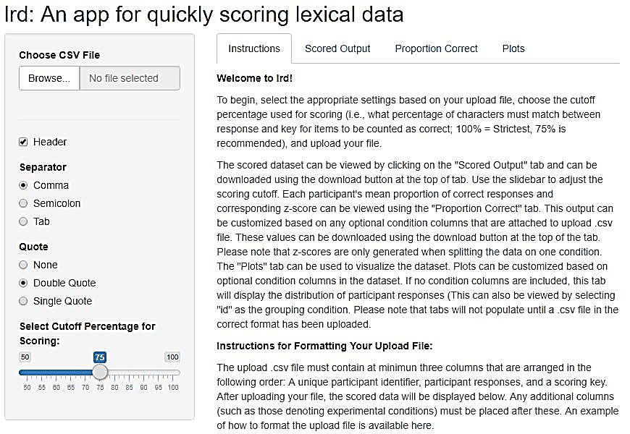

*Figure 1.* Illustration of the *lrd Shiny* application’s Instructions tab prior to uploading a dataset.

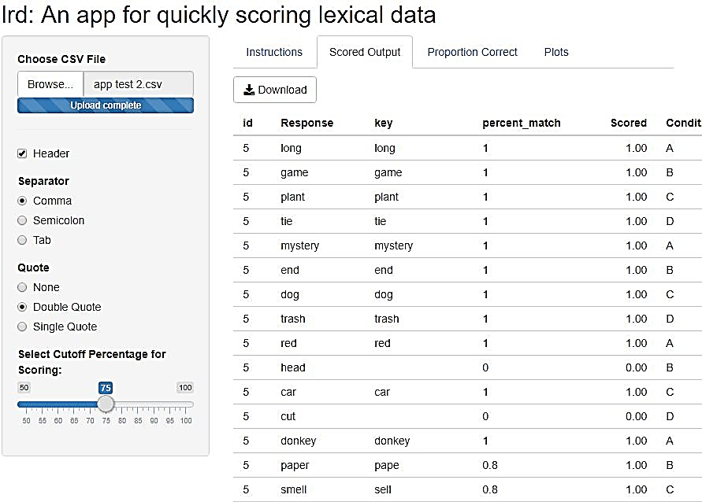

*Figure 2.* Illustration of the *lrd Shiny* application’s Scored Output tab after uploading a dataset. Data in this is example is scored using a 75% cutoff criteria.

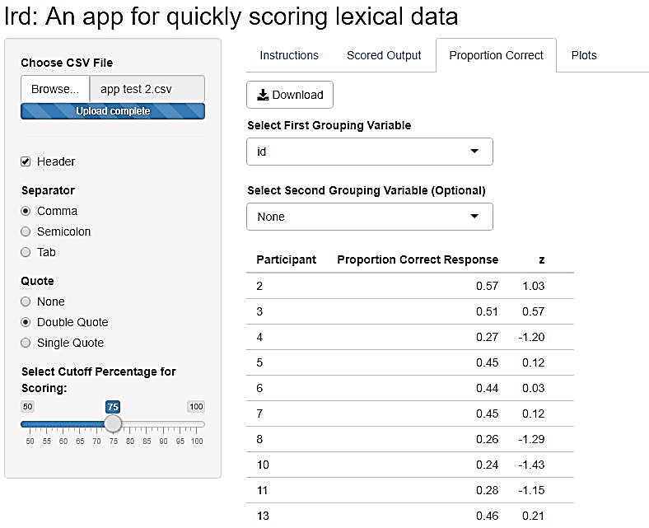

*Figure 3*. Illustration of the lrd Shiny application’s Proportion Correct tab. Data is grouped by participant identifier.

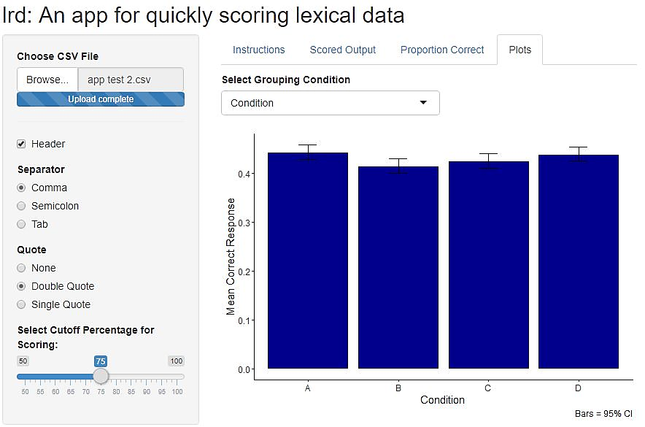

*Figure 4*. Illustration of the lrd Shiny application’s Plots tab. Data in this example is grouped by an optional condition column attached to the upload .csv file.